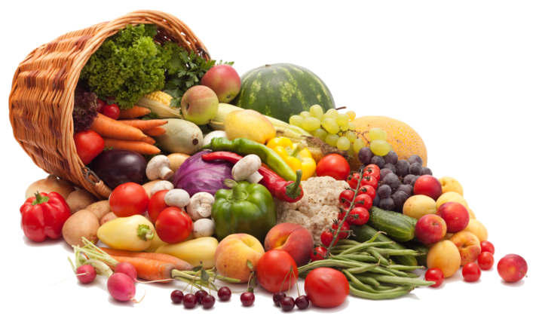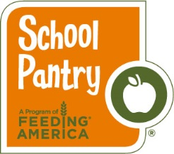 **J.W. Dobbs Elementary School Mobile Market**

**A mobile market in partnership with the Atlanta Community Food Bank. Free while quantities last – Eligible to all families at the participating school.**

Come participate in a monthly market featuring assorted food items and **fresh produce!** Families may receive approximately 30 lbs of food items free of charge to take home and prepare. **DON’T FORGET TO BRING BAGS OR A CART!!**

**Date: Wednesday, March 8, 2023**

**Time: 3:00p.m.-5:00 p.m.**

**Where: Gymnasium**



